POSEIDON v46.3
Product-Wide ERD & Data Architecture
Gemi + Römorkör • Domain Model • Veri Sahipliği • Audit • Evidence • Integration

1. Mimari Karar
POSEIDON veri modeli ekran-merkezli değil, domain ve yaşam-döngüsü merkezli kurulacaktır. 196 ekran aynı entity'lerin farklı rol/context projection'larıdır; ekran başına ayrı tablo oluşturulmayacaktır. Gemi ve Römorkör aynı çekirdek Tenant/Company/Vessel/Person/Asset/Evidence/Audit altyapısını kullanır; TugJob/TowagePlan/TowageExecution gibi römorköre özgü aggregate'lar yalnız Tug Mode'da aktive olur.
- Tenant isolation her business entity'de tenant_id veya tenant-scope yoluyla korunur.
- Vessel tek çekirdek entity'dir; VesselProfile ve TugProfile type-specific extension'dır.
- Effective dating: requirement, rule, assignment, certificate, document, competence gibi değişebilir kayıtlar valid_from/valid_to veya version taşır.
- Soft-delete yalnız operasyonel master-data için; legal/audit/evidence kayıtlarında immutable/superseded yaklaşımı tercih edilir.
- Completed, Verified ve Effective ayrı state'lerdir.
- Evidence lineage source → object → verification → decision → readiness zincirinde korunur.

2. Product-Wide Domain ERD
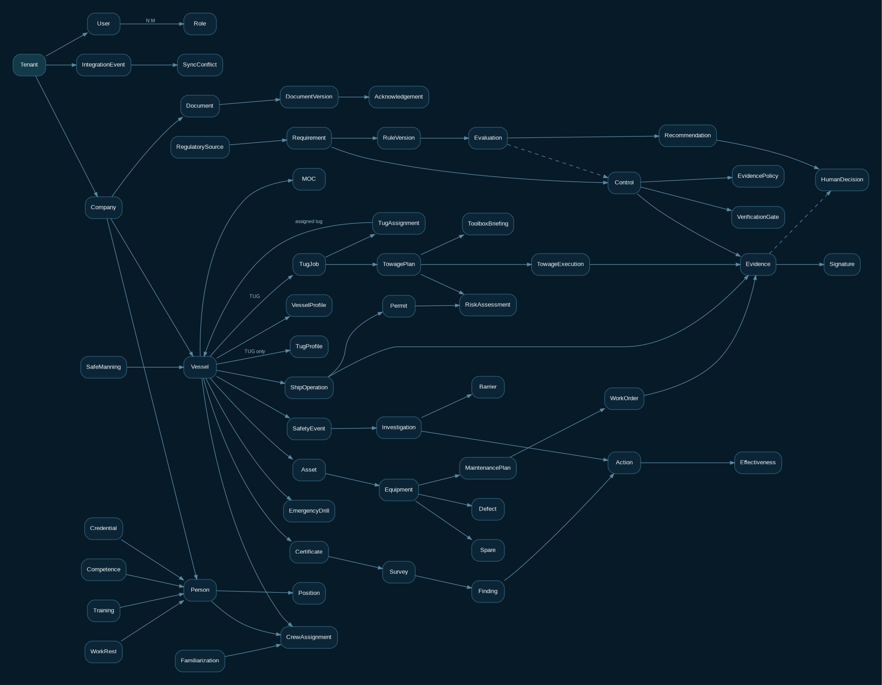
Şekil 1 - Ürün geneli domain ilişkileri. Diyagram fiziksel kolonların tamamını değil aggregate sınırlarını gösterir.

3. Domain Grupları ve Sistem-of-Record
Domain | Başlıca Entity'ler | SoR | Kritik Not
Core / IAM | Tenant, Company, User, Role, Permission, Delegation | POSEIDON / IdP | Tenant ve authorization sınırı.
Fleet / Vessel | Vessel, VesselProfile, TugProfile, Registry, Capability | POSEIDON | Gemi ve römorkör tek Vessel kökünde.
People / Crew | Person, Position, CrewAssignment, Credential, Competence, Training, WorkRest, Familiarization, SafeManning | POSEIDON + HR/Crewing integration | Medical ayrıntı minimum-data; çoğunlukla validity/status.
Ship Operations | ShipOperation, VoyageContext, Permit, Bunkering, CargoOperation | POSEIDON | Port OS değil; geminin kendi operasyon kayıtları.
Tug Operations | TugJob, TugAssignment, TowagePlan, TowageBriefing, TowageExecution, TugDailyLog | POSEIDON | Kendi römorkör iş planlama/yürütme.
Safety / HSE | SafetyEvent, Investigation, RiskAssessment, Barrier, StopWork, Observation, Action, Effectiveness, MOC | POSEIDON | HSE bağımsız domain.
Technical | System, Asset, Equipment, MaintenancePlan, WorkOrder, Measurement, Defect, Spare, InventoryTxn, DryDockJob | POSEIDON + ERP/IoT optional | Critical equipment/readiness.
Knowledge | Document, DocumentVersion, ControlledCopy, Acknowledgement, FleetNotice | POSEIDON / object storage | Versioned/controlled.
Assurance | Audit, Inspection, Finding, Survey, Certificate, ClassCondition, PSCRecord | POSEIDON + class/RO evidence | Source-specific lifecycle.
Regulatory | RegulatorySource, Requirement, RuleVersion, Evaluation, Activation, Conflict, EvidencePolicy, VerificationGate | POSEIDON | Dynamic Applicability Engine.
Evidence / Decision | Evidence, EvidenceLink, Verification, Signature, HumanDecision, AuditEvent | POSEIDON | Cross-domain legal trace.
Integration | Connector, ExternalObjectMap, IntegrationEvent, OutboxMessage, WebhookDelivery, SyncConflict | POSEIDON Integration Hub | Idempotent and replayable.
Intelligence | Signal, Recommendation, ModelRun, Explanation, DecisionFeedback | POSEIDON | AI is advisory; human authority preserved.

4. Çekirdek Entity Sözleşmeleri
Entity | Temel Alanlar | Amaç
Tenant | id, code, name, status, default_language, timezone | Root security/ownership boundary.
Company | id, tenant_id, imo_company_no?, legal_name, country, sms_scope | Ship/tug operating company.
Vessel | id, tenant_id, company_id, name, imo_no?, official_no?, flag, vessel_type, status | Common ship+tug root.
VesselProfile | vessel_id, gt, nt, dwt, loa, breadth, draft, build_date, trading_area | Regulatory applicability facts.
TugProfile | vessel_id, tug_type, propulsion_type, bollard_pull, fifi_class, winch_type, tow_hook, escort_capability | Tug-specific facts.
Person | id, tenant_id, external_hr_id?, name, nationality?, employment_state | PII minimization required.
Position | id, tenant_id, code, name, department, shipboard_role | No position-group substitution in competence matrix.
CrewAssignment | person_id, vessel_id, position_id, from/to, status, source | Assignment lineage.
Credential | person_id, type, number/token, issuer, issue/expiry, limitations, verification_state | Validity + provenance.
Asset | id, vessel_id, parent_asset_id, system, criticality, maker/model/serial | Hierarchy Vessel→System→Equipment→Component.
WorkOrder | asset_id, maintenance_plan_id, due, completion, verification, evidence_state | Completed ≠ Verified.
SafetyEvent | vessel_id, type, occurred_at, severity, description, immediate_action, status | Event lifecycle.
DocumentVersion | document_id, version, effective_from, status, hash, storage_ref | Immutable published versions.
Certificate | vessel_id, type, issuer, issue/expiry, survey_window, verification_state | Statutory/class register.
RegulatorySource | source_id, authority, title, locator, version, lifecycle, effective_dates | Authoritative source record.
RuleVersion | rule_id, source_id, predicate, outcome, effective_dates, approval_state | Versioned, approved publication.
Evidence | id, tenant_id, object_type/id, evidence_type, source, captured_at, hash, storage_ref, provenance_state | Cross-domain proof.
Verification | evidence_id/control_id, verifier, result, verified_at, reason | Human gate.
HumanDecision | subject_type/id, decision, actor_role, actor_id, reason, evidence_context, decided_at | Master/Tug Master/DPA/authorized role.

5. Evidence ve Decision Trace
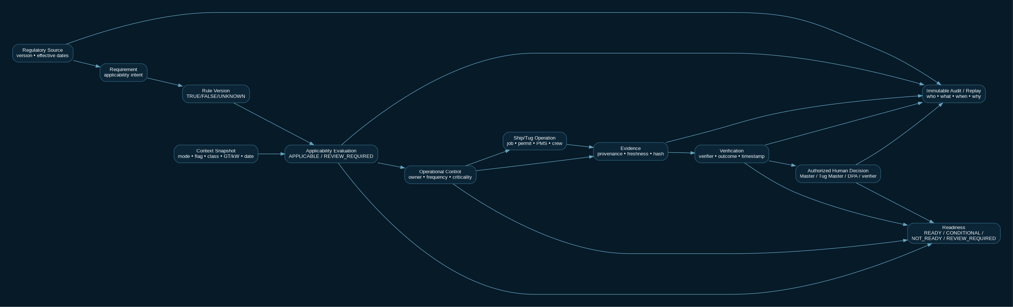
Şekil 2 - Source → Requirement → Rule → Control → Evidence → Verification → Human Decision → Readiness zinciri.

6. Fiziksel Veri Kuralları
- Primary key: UUID/ULID. Kullanıcıya gösterilen iş numaraları ayrı controlled sequence'tir.
- tenant_id business tablolarında zorunlu; global regulatory source/rule kayıtlarında tenant_id NULL olabilir.
- Optimistic concurrency: mutable aggregate'larda row_version / xmin / ETag karşılığı.
- AuditEvent append-only: actor, role, tenant, object, action, before/after summary, correlation_id, device/source, timestamp.
- Evidence binary içerik DB'de değil object storage'da; DB'de immutable metadata, hash, MIME, size, storage_ref.
- PII ve özellikle health/protected-report data ayrı access policy ve field-level redaction projection kullanır.
- Tarih/saat: server UTC; ship/tug local timestamp ve offset ayrıca saklanabilir. Audit chronology UTC canonical'dır.
- Enum yerine source-governed lookup gereken alanlar effective-dated master-data kullanır.
- Hard delete: yalnız staging/import temp data. Published rule, evidence, verification, signed decision, audit event silinmez; supersede/revoke edilir.

7. State Machine Örnekleri
AÇIK KARAR D-STATE-01: Bu belgedeki TugJob/WorkOrder durumları henüz tek uygulama enum sözleşmesi değildir. 06.01 §6 TugJob için NEW/PLANNING/ASSIGNED/READY/IN_PROGRESS/COMPLETED/CANCELLED kullanırken 14.01 §7 DRAFT/PLANNED/READINESS_REVIEW/RELEASED/SUSPENDED/ABORTED/VERIFIED/CLOSED dahil genişletilmiş bir yaşam döngüsü örneği verir. 13.04 work-item sözlüğü de WorkOrder geçişleriyle uzlaştırılmalıdır. PO/BA, Architect, Marine/Tug SME ve QA; command, from/to, guard, yetki, version, audit, offline ve hata sonucunu içeren geçiş matrisini onaylamadan bu değerler production enum veya otomatik geçişe dönüştürülmez. Kritik uygulama akışının Development Freeze kabulü bu karar kapanana kadar OPEN kalır.
Aggregate | State
TugJob | DRAFT → PLANNED → ASSIGNED → READINESS_REVIEW → RELEASED → IN_PROGRESS → SUSPENDED/ABORTED → COMPLETED → VERIFIED → CLOSED
WorkOrder | PLANNED → RELEASED → IN_PROGRESS → COMPLETED → VERIFICATION → CLOSED / REOPENED
Evidence | CAPTURED → PENDING_VERIFICATION → VERIFIED / REJECTED → SUPERSEDED / EXPIRED
Finding | OPEN → CONTAINED → ACTIONING → VERIFICATION → CLOSED
RuleVersion | DRAFT → IN_REVIEW → APPROVED → PUBLISHED/FUTURE_EFFECTIVE → IN_FORCE → SUPERSEDED
Certificate | VALID → DUE_SOON → SURVEY_WINDOW → EXPIRED/SUSPENDED → RENEWED/SUPERSEDED

8. Integration Architecture
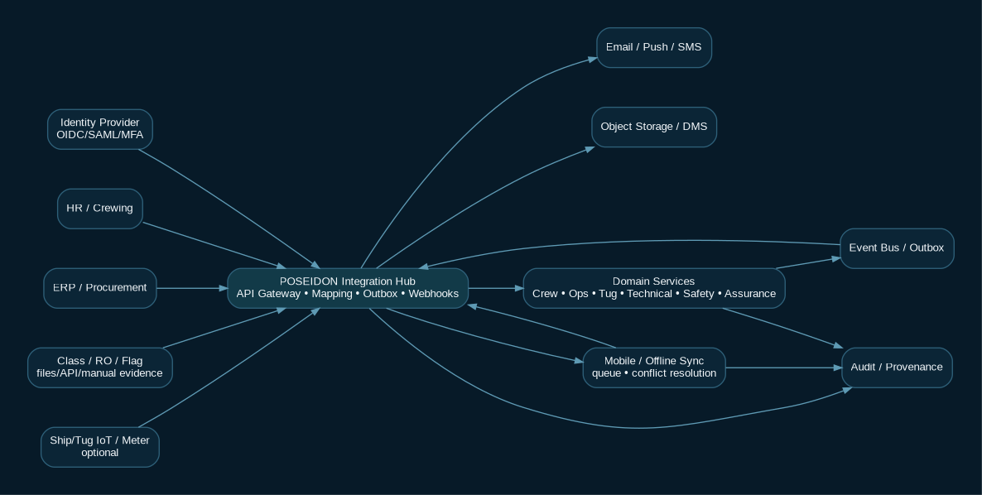
Şekil 3 - Integration Hub, domain services, offline sync ve audit/provenance sınırı.

9. Offline ve Conflict Veri Modeli
Entity | Temel Alanlar | Kural
OfflineCommand | command_id, device_id, tenant_id, aggregate, action, payload, captured_at, base_version | Client queue.
SyncReceipt | command_id, server_received_at, result, resulting_version | Idempotent receipt.
SyncConflict | aggregate, local_version, server_version, materiality, local_delta, server_delta, status | Material safety/legal conflict human resolution.
OfflineSnapshot | rule_set_version, screen/data projection version, valid_until | Stale/expired critical rules READY üretmez.
MergeDecision | conflict_id, resolution, actor, reason, decided_at | No silent last-write-wins for material data.

10. Index / Partition Önerileri
- tenant_id + vessel_id + state/due_date: operational lists.
- tenant_id + person_id + credential_type + expiry: crew readiness.
- tenant_id + vessel_id + criticality + due: PMS/defect.
- tenant_id + tug_id + scheduled_start/end: tug assignment overlap.
- source_id + rule_id + version + effective dates: applicability.
- evidence(object_type, object_id, evidence_type, captured_at DESC): evidence history.
- audit_event partition by month/quarter for high volume; immutable archive policy.
- IntegrationEvent/outbox status + next_attempt_at + correlation_id: reliable delivery.

11. Data Retention & Legal Hold
Record Class | Default Model | Not
Regulatory source/rule/history | Permanent version history while product supports affected historical records | Delete only via controlled archive policy.
Audit / signed decision | Immutable long retention | Legal hold supported.
Operational evidence | Policy-driven by regulation/contract/record type | RetentionRule entity.
Crew PII | Purpose-limited; employment/assignment/legal retention | Minimize and restrict.
Protected report | Restricted, minimum identity exposure | Separate access policy.
Telemetry | Shorter high-volume retention + aggregated history | Raw/derived separation.

12. Development Freeze Acceptance Criteria
- Every controlled screen maps to a domain projection; no screen-specific table is created without domain justification.
- All critical aggregates carry tenant + authorization scope.
- Gemi ve Römorkör share common Vessel/Person/Asset/Evidence/Audit roots.
- TugJob/Towage objects cannot introduce Port Management entities.
- Evidence can link to Requirement/Control/Operation/WorkOrder/Event/Certificate/Survey.
- Completed/Verified/Effective states remain independent.
- Regulatory rule history is reproducible for historical dates.
- Offline conflict is explicit for safety/legal material fields.
- PII/sensitive data is not copied into AI logs or broad fleet projections by default.
- Database schema and API contracts use the same IDs/state vocabulary.

13. Geliştirme Sırası
Sprint/Track | Data Model Önceliği
Foundation | Tenant, Company, User/Role, Vessel, Person, Audit, Evidence, Document, Regulatory source/rules
Crew | Position, assignment, credential, competence, training, MSMD, work/rest, familiarization
Technical | Asset hierarchy, PMS plan, work order, defect, spare, measurement
Ship Operations | Operation, permit, RA, briefing, voyage/departure/cargo context
Tug Operations | TugJob, assignment, readiness snapshot, towage plan/briefing/execution/log
Safety/Assurance | Event, investigation, barrier, action/effectiveness, audit/finding/certificate/survey
Intelligence | Signal, recommendation, decision feedback, model run/evaluation
Integration/Offline | Connector, mapping, outbox, webhook, offline command/conflict/receipt

14. Sonuç
Bu ERD/Data Architecture v46.3 için ürün geneli kontrollü aday teknik tasarımdır; uygulama ve fiziksel DB doğrulaması değildir. Uygulama geliştirirken ekran veya müşteri bazında veri yapısı çoğaltılmamalı; yeni ihtiyaçlar mevcut domain aggregate'a eklenmeli veya Change Control ile yeni aggregate olarak gerekçelendirilmelidir.

15. v46.3 Yeni / Güçlendirilen Domain Entity’leri
Entity | Aggregate Parent | Temel Alanlar | Kural
NoonReport | Vessel/Voyage | position, activity, speed, weather, fuel, ROB, ETA, Master review | Downstream projections reuse; offline.
DeckDailyLog | Vessel/Watch | watch, OOW, nav/port/cargo/tug/pilot, handover | Watch evidence.
EngineDailyLog | Vessel/Watch | engine hours, fuel/lube, measurements, alarms, defects, WO, handover | Technical daily evidence.
FuelBunkerLog | Vessel | transaction type, fuel, tank, qty, ROB, BDN, quality, verification | Regulatory/evidence-aware.
PortActivitySOF | Voyage | event type/time, pilot/tug/cargo/delay, evidence | Own-vessel activity only.
OperationalDowntime | Vessel/Operation | start/end/cause/impact, defect/WO/event, claim candidate | No finance SoR.
ServiceEngineerReport | Equipment/WO | provider, work, parts, tests, defects, recommendations, evidence | Immutable service history.
PreSurveyChecklist | Survey/Certificate | item, owner, due, evidence, verification, finding, voyage-fit | Readiness input.
RiskTemplate | Safety | revision/effective date, hazards/controls/barriers, suggestions | Published version immutable.
HighRiskWorkProjection | Projection | risk/permit/barrier/crew/equipment/owner/why | Read-only aggregate projection.

16. v46.3 Veri Sınırı
- PortActivitySOF içinde port/terminal adları context olarak tutulabilir; Berth/Terminal/PortTraffic aggregate oluşturulmaz.
- OperationalDowntime içinde Loss-of-Hire candidate tutulabilir; AP/AR/claim accounting burada system-of-record değildir.
- Critical spares/inventory yalnız teknik bakım/readiness amacıyla sınırlıdır; enterprise warehouse/finance master data dış sistemdedir.
- New daily logs duplicate master-data yaratmaz; Vessel/Voyage/Person/Asset/Credential/Requirement/Evidence canonical entity’lerine referans verir.

